# Astro 205: Problem set 5

## Question 2

$$m\left(r\right)= \int_{0}^{r}{ρ\left(r\right)*dV}$$

$$m\left(r\right)= \int_{0}^{r}{ρ_{c}\left(1-\frac{r}{R}\right)*dV}$$

$$Where, ρ_{c} is the central density of the sun converted to kgm^{-3} and R is the solar radius$$

Since,

$$V=\frac{4}{3}πr^{3}$$

$$\frac{dV}{dr}=4πr^{2}$$

So,

$$dV=4πr^{2} dr$$

Thus,

$$m\left(r\right)= \int_{0}^{r}{ρ_{c}\left(1-\frac{r}{R}\right)*4πr^{2} dr}$$

$$m\left(r\right)= \int_{0}^{r}{4πr^{2}ρ_{c}-\frac{4πρ_{c}}{R}}r^{3} dr$$

When evaluated,

$$m\left(r\right)=\frac{4}{3}πρ_{c}r^{3}-\frac{ρ_{c}πr^{4}}{R}$$

## Question 3

$$m\left(R\right)= \int_{0}^{R}{4πr^{2}ρ_{c}-\frac{4πρ_{c}}{R}}r^{3} dr$$

$$M= \frac{4}{3}πρ_{c}R^{3}-ρ_{c}πR^{3}$$

$$M=\frac{1}{3}πρ_{c}R^{3}$$

## Question 4

Hydrostatic Equilibrium,

$$\frac{dP}{dr}= -\frac{GM\left(r\right)ρ\left(r\right)}{r^{2}}$$

$$dP= -\frac{GM\left(r\right)ρ\left(r\right)}{r^{2}}dr$$

$$dP= -\frac{G\left(\frac{4}{3}πρ_{c}r^{3}-\frac{ρ_{c}πr^{4}}{R}\right)\left(ρ_{c}\left(1-\frac{r}{R}\right)\right)}{r^{2}} dr$$

$$\int_{P_{c}}^{0}{dP= \int_{0}^{R}{-\frac{G\left(\frac{4}{3}πρ_{c}r^{3}-\frac{ρ_{C}πr^{4}}{R}\right)\left(ρ_{C}-\frac{ρ_{c}r}{R}\right)}{r^{2}} dr}}$$

$$\int_{0}^{P_{c}}{dP}= \int_{0}^{R}{\frac{G\left(\frac{4}{3}πρ_{c}r^{3}-\frac{ρ_{C}πr^{4}}{R}\right)\left(ρ_{C}-\frac{ρ_{c}r}{R}\right)}{r^{2}} dr}$$

$$\int_{0}^{P_{c}}{dP}=\int_{0}^{R}{\frac{\frac{4}{3}Gπρ_{c}^{2}r^{3}-\frac{4}{3R}Gπρ_{c}^{2}r^{4}-\frac{G{πρ}_{c}^{2}r^{4}}{R}+\frac{Gπρ_{c}^{2}r^{5}}{R^{2}}}{r^{2}} dr}$$

$$\int_{0}^{P_{c}}{dP}=\int_{0}^{R}{\frac{4}{3}Gπρ_{c}^{2}r-\frac{4}{3R}Gπρ_{c}^{2}r^{2}-\frac{Gπρ_{c}^{2}r^{2}}{R}+\frac{Gπρ_{c}^{2}r^{3}}{R^{2}}dr}$$

$$P_{c}=\frac{2}{3}Gπρ_{c}^{2}R^{2}-\frac{4}{9}Gπρ_{c}^{2}R^{2}-\frac{Gπρ_{c}^{2}R^{2}}{3}+\frac{Gπρ_{c}^{2}R^{2}}{4}$$

$$P_{c}=Gπρ_{c}^{2}R^{2}\left(\frac{2}{3}-\frac{4}{9}-\frac{1}{3}+\frac{1}{4}\right)$$

$$P_{c}=\frac{5Gπρ_{c}^{2}R^{2}}{36}$$

## Question 5

$$M=\frac{1}{3}πρ_{c}R^{3}$$

$$ρ_{C}=\frac{3M}{{πR}^{3}}$$

## Question 6

$$P_{c}=\frac{5Gπρ_{c}^{2}R^{2}}{36}$$

$$P_{c}=\frac{5GπR^{2}}{36}{\left(\frac{3M}{πR^{3}}\right)}^{2}$$

$$P_{c}=\frac{5GM^{2}}{4πR^{4}}$$

## Question 7

$$\int_{P\left(r\right)}^{P_{C}}{dP}=\int_{0}^{r}{\frac{4}{3}Gπρ_{c}^{2}r-\frac{4}{3R}Gπρ_{c}^{2}r^{2}-\frac{Gπρ_{c}^{2}r^{2}}{R}+\frac{Gπρ_{c}^{2}r^{3}}{R^{2}}dr}$$

$$P_{C}-P\left(r\right)=\frac{2}{3}Gπρ_{c}^{2}r^{2}-\frac{4}{9R}Gπρ_{c}^{2}r^{3}-\frac{1}{3R}Gπρ_{c}^{2}r^{3}+\frac{1}{4R^{2}}Gπρ_{c}^{2}r^{4}$$

$$P_{C}-P\left(r\right)=Gπρ_{c}^{2}\left(\frac{2}{3}r^{2}-\frac{7}{9R}r^{3}+\frac{1}{4R^{2}}r^{4}\right)$$

$$P\left(r\right)= \frac{5GM^{2}}{4πR^{4}}-Gπ{\left(\frac{3M}{πR^{3}}\right)}^{2}\left(\frac{2}{3}r^{2}-\frac{7}{9R}r^{3}+\frac{1}{4R^{2}}r^{4}\right)$$

$$P\left(r\right)=\frac{5GM^{2}}{4πR^{4}}-\frac{9GM^{2}}{πR^{6}}\left(\frac{2}{3}r^{2}-\frac{7}{9R}r^{3}+\frac{1}{4R^{2}}r^{4}\right)$$

This equation can be seen to be valid since P(r=R) equates to 0. Which is true for the pressure of a star at its surface.

## Question 8

The equation of state (derived from the ideal gas law):

$$P=\frac{\left(\frac{1}{μ}\right)κρT}{m_{H}}$$

Where $μ$ is the mean molecular mass

$κ$ is the Boltzmann constant

$m_{H}$ is the mass of Hydrogen which will be taken as the mass of a proton

$$\frac{1}{μ}=2X+\frac{3}{4}Y+\frac{1}{2}Z$$

Where X is the Hydrogen mass fraction, Y is Helium mass fraction and Z is the mass fraction of all heavier particles. The given values of X, Y and Z are 0.74,0.24,0.02 respectively.

Thus $μ is 0.5988 m_{H}^{-1}$

Making T the subject of the function,

$$T=\frac{m_{H}P(r)μ}{κρ(r)}$$

$$T=\frac{m_{H}μ\left(\frac{5GM^{2}}{4πR^{4}}-\frac{9GM^{2}}{πR^{6}}\left(\frac{2}{3}r^{2}-\frac{7}{9R}r^{3}+\frac{1}{4R^{2}}r^{4}\right)\right)}{κ\left(\frac{3M}{πR^{3}}\left(1-\frac{r}{R}\right)\right)}$$

For central temperature, formulate T when r is 0

$$T_{c}=\frac{m_{H}μ\left(\frac{5GM^{2}}{4πR^{4}}\right)}{κ\left(\frac{3M}{πR^{3}}\right)}$$

Which is that same as

$$T_{c}=\frac{m_{H}μP_{c}}{κρ_{c}}$$

## Question 9

Evaluating $ρ_{c}, P_{c} and T_{c}$ and comparing them to the values given

$$ρ_{c}=\frac{3M}{πR^{3}}=5633.502 kgm^{-3}$$

$$P_{c}=\frac{5GM^{2}}{4πR^{4}}= 4.477*{10}^{14} Nm^{-2}$$

$$T_{c}=\frac{m_{h}μ\left(\frac{5GM^{2}}{4πR^{4}}\right)}{κ\left(\frac{3M}{πR^{3}}\right)}=5.756*{10}^{6} K$$

These numbers differ from the given standard solar model. This is most likely due to the fact that the derivation above does not take into account the nuclear energy generation that takes place in the sun, that would in theory increase the pressure, density and temperature at the core of the sun. The derivation above also does not take into account the radiative transfer from within the sun (towards the surface).

Plotting the mass, pressure and temperature of the sun as a function of its radius from the centre and comparing it the plots of the standard solar model we get the following illustrations.

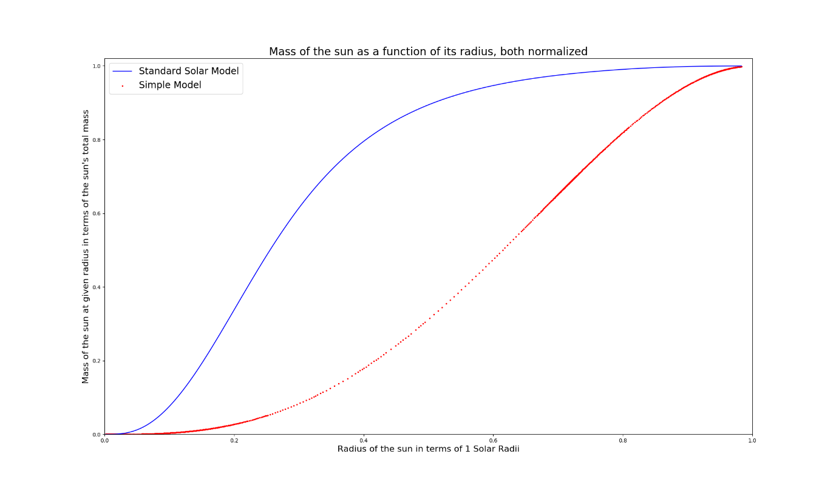

The standard solar model shows that the mass of the star increases incrementally until 0.4 solar radii. Then, at which it increases almost logarithmically up to 1 solar radii, plateauing. Whereas the simple model illustrates that the mass of sun increases parabolically up to 1 solar radii.

The difference in the two models must be because the real density function must also take into account the nuclear reactions taking place at the core of the sun, and in turn altering how the mass truly changes with radius.

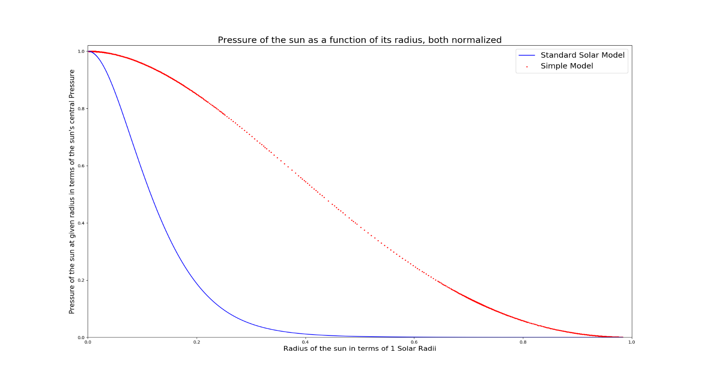

According to the standard solar model, the pressure falls almost exponentially with solar radius. Whereas the simple falls more gradually. This must be because most the most of the force acting from the sun comes from the core, where nuclear reactions take place. Thus, as distance from the sun increase, and leave the core, the pressure drastically decreases.

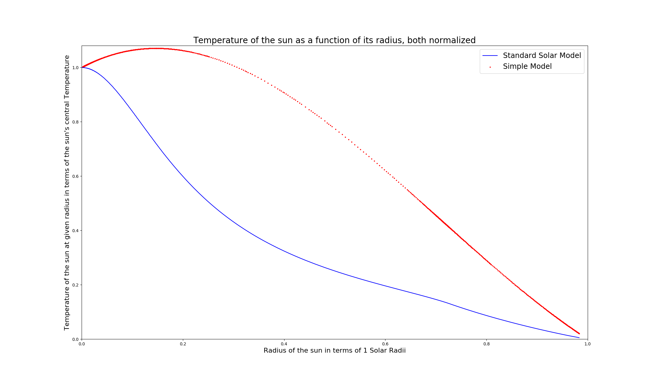

According to the standard solar model, the temperature falls quite quickly at beginning, and drops at a slower, almost linear rate nearing to the surface of the sun. We can see that the temperature function of the simple model is incorrect and does not take into account the nuclear fusion and the radiative transfer between the core and the photosphere as the temperature start to increase (above the central temperature) as the distance begins to increase. However, it does begin to drop after the distance goes beyond 0.2 solar radii.